Using metaheuristics to design quantum experiments
This is a collaborative project with Maths, and Paul Knott will be acting as co-supervisor.
Designing experiments in quantum physics is a channelling task, which is made even more difficult by the counterintuitive nature of the theory. To overcome this, we are using computer algorithms to design quantum experiments for us. We are specifically interested in experiments involving light. Each experiment generally involves inputting numerous quantum states of light, operating on these several times, then performing measurements. This produces an output state, which can be used for a range of applications and experimental tests.
Such an experiment is illustrated below. We have N inputs (I₁-I_{N}), K operators (O₁-O_{K}), and N-1 measurements (M₁-M_{N-1}). There are I possible options for each input I_{j}, as well as O different options for each O_{j}, and M different options for each M_{j}. The total number of different configurations is therefore given by: I^{N} x O^{K} x M^{N-1}. In addition, each input, operator and measurement has 2 parameters (positive real numbers) that need to be chosen. Our goal is to find the best arrangement/setting of inputs, operators and measurements (and their parameters) to produce a final output with a target objective value (we wish to maximise the objective value).
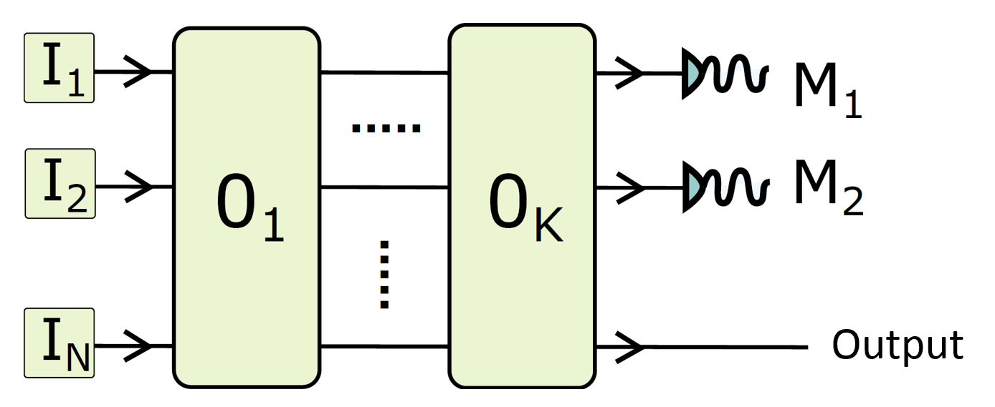
This project involves designing and implementing an effective approach underpinned by a chosen metaheuristic (e.g., simulated annealing, iterated local search, selection hyper-heuristic) communicating with a simulator for each evaluation of a setting/solution for optimal design of quantum experiments. The simulator is already implemented and an interface will be provided in C/C++ and Matlab. The time spent on an invocation of the objective function can be costly depending on the predefined precision setting of the simulator. Hence, this approach should consider not only the mixture of discrete (e.g., I_{j}) and real-valued variables (e.g., parameters of each input), but also the overall search speed returning a high quality solution in a reasonable amount of time. The proposed approach is expected to introduce its own parameters and tuning of those parameters will be part of the project, regardless of the metaheuristic chosen for solving this challenging problem. A benchmark of instances will be provided for testing of the proposed approach.

